# **Project Initialization and Planning Phase**

|  |  |
| --- | --- |
| Date | 28-07-2025 |
| Team ID | Simran Gupta |
| Project Name | Predicting Plant Growth Stages with Environmental and Management Data Using Power BI |
| Maximum Marks | 3 Marks |

**Problem Statements:**

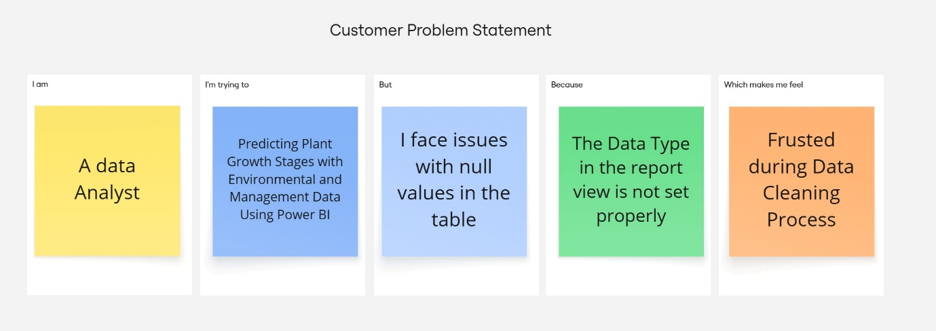The Customer Problem Statement helps you focus on what matters to create experiences people will love. A well-articulated customer problem statement allows you and your team to find the ideal solution for your customers' challenges. Throughout the process, you’ll also be able to empathize with your customers, which helps you better understand how they perceive your product or service.

|  |  |  |  |  |  |
| --- | --- | --- | --- | --- | --- |
| **Problem**  **Statement**  **(PS)** | **I am**  **(Customer)** | **I’m trying to** | **But** | **Because** | **Which makes me feel** |
| PS-1 | A smallscale farmer | Improve crop yield using smart irrigation | I don't have access to datadriven insights | Traditional methods don’t tell me when and how much  to irrigate | Frustrated and unsure about making the right farming decisions |
| PS-2 | An agricultural officer | Track the efficiency of irrigation systems in different regions | Data from farms is unorganized and hard to interpret | There's no centralized tool that visualizes performance in real-time | Inefficient in decision-making and overwhelmed |
| PS-3 | A farm equipment distributor | Understand what kind of irrigation solutions are most needed | I don’t know what challenges farmers face with irrigation or crop growth | I lack real-time, location-based insights | Uncertain about customer needs and how to market  effectively |
| PS-4 | An agri-tech consultant | Recommend  sustainable farming practices | I don’t have visual data to support my analysis | My clients can’t understand raw data without visuals | Less convincing, and my advice feels less credible |